Lewis Reed
s3683186
Website URL:
http://lewisintro2.s3-website-ap-southeast-2.amazonaws.com

Personal Information

My name: Lewis Eldon Reed
My student number: s3683186
My email: Eldonlewisreed@gmail.com

Background
I was born in Fremantle, Western Australia, in 1992. Growing up, my house was never empty. I grew up in a suburban home with my two parents and five siblings; two younger and three older; two girls and four boys. We kept five chickens, all named Betty, a dog and a cat.

My friends refer to me as Lewis or Lewi. My mother had always thought that I would perhaps prefer to be referred to by my middle name, Eldon. My middle name is a reference to John Scott, the first Earl of Eldon, who was born in Newcastle upon Tyne – where both of my parents are originally from - in the early 18th century. My entire extended family lives in the UK, with the majority still living in regions in the north of England. I'm a second generation immigrant in Australia.

At the age of twenty one I emigrated to Germany where I remained for three years. Over this time I learned to speak German at a conversational level, taking night classes to advance faster. For work, I moved between cafe jobs making coffee and working the bar at venues hosting dance events organised by people that I knew at the time. While here I also rented a studio in which I continued to create art.

Education
I've studied twice before at a University level. The first was at the University of Western Australia where for a single semester I studied Podiatric Medicine. I had chosen this direction of study based on the subjects I had enjoyed in high school, and eventually aiming to transfer into the mainstream Medicine course. I quickly realised that a life in the Medical field was not right for me, and in the following semester I began a degree in Fine Art at Curtin University.

Hobbies
Alongside my passion for creating visual art I have since early high school enjoyed experimenting with digital music production on Digital Audio Workspaces such as Ableton Live and Logic Pro. I hope to at some point in time release a record that I am satisfied with.

Interest in IT

My current primary interest in IT surrounds the creation of programs and platforms related to the listening and manipulation of music and sound. This interest extends from online services such as Soundcloud and LANDR, to the creation of new and interesting plug-ins as well as conceptualising alternative approaches for a digital audio workspaces. My interest in IT began in early high school when I began playing online games, and found a community of people that ran personal websites for their blogs and gaming teams. I wanted to create my own website so I obtained a copy of DreamWeaver and taught myself basic HTML. My website was very simple and hosted download links for scripting software used to cheat in online games such as Habbo Hotel and Counter Strike. I hosted my own website through a domain held by my dad. This website added nothing of value as it was basically an emulation of the others I'd seen, but in building it I was able to learn that I can harness the computer as a tool to channel my creativity.

I first discovered RMIT during my visits to Melbourne years prior to my move here. I loved the seamless transition from lecture halls to the loud inner city as you stepped onto the street. I researched online the course structures at all of prominent Universities in Melbourne that offered the Bachelor of IT, and noted that the third year of the course offered at RMIT had a large portion of practical work that was perfect for what I wanted from the degree. I was impressed with the selection of affiliate universities that offered exchange programs with RMIT students, specifically the Technische Universität in Berlin where I had previously looked at enrolling into while living in Berlin.

Ideal Job

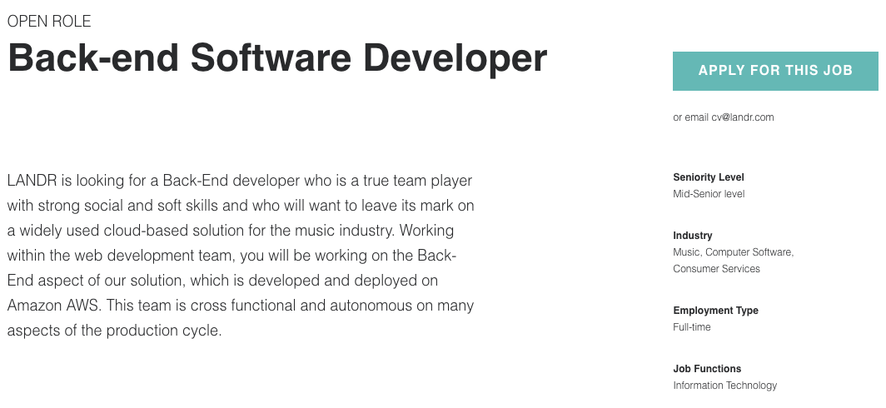
URL: https://jobs.landr.com/backend-dev

Description
LANDR is a website and desktop application that provides instant online audio-mastering of music tracks for its customers. It also offers distribution services for artists, giving access to the artist's music across a range of streaming services.

The advertised positions is of mid-senior level. The style of workflow will be consistent with the Agile development methodology. This means working within a team - commonly ranging from 3-9 people – to create outcomes within timeframes called 'sprints', with progress tracked via daily meat ups called 'scrums'. It is a backend developer role, creating data-models using NoSQL and SQL databases as well as developing Restful APIs using object oriented C# design. solutions on a range of aspects within the production cycle.

Having spent a lot of time producing music as a hobby (I've even personally used LANDR on many occasions), I've formed a strong interest in technology and services such as LANDR that are built to empower artists in music production. This position would give me the opportunity to build upon my current knowledge in audio processing. Finding myself working within a team would be preferable; I've found that in the context of programming, working as a team yields superior results, as the capacity to brainstorm ideas from multiple perspectives promotes abstract approaches in design.

Skills, qualifications and experience required
For this job, it is expected that the applicant has already gained +3 years of experience with product-oriented companies and is familiar with service-oriented architecture and test-driven development. A strong skillset in C# is required as well as experience in data-modelling with NoSQL and SQL databases. LANDR is deployed on Amazon AWS, and as such experience with it and/or other cloud-based hosting environments is necessary. The applicant must possess strong analytical skills and be naturally self-motivated.

LANDR aims to provide an automated alternative to professional audio mastering. To design a product equipped to handle varying styles of music, it is expected that the developer understands the ways in which differing methods of music production will affect sound. Therefore, having the capability to produce solutions to the challenges faced within this role also requires knowledge in sound engineering.

Skills, qualifications and experience I currently have
The only programming knowledge I currently possess is in Java. Currently I am in enrolled in Programming 1, so I would classify this as still at a beginner's level. I do believe I have a good grasp on Object-Oriented design methodology, at least in my understanding of how to write it, the reason for its popularity and its capability.

I have limited knowledge in creating SQL data-models, HMTL and CSS. I currently have a moderate understanding of processing audio and sound within a digital workspace, this is not however supported by a solid mathematical understanding of sound.

My plan to attain the relevant skills, experience and qualifications
Alongside my studies, I have been attempting to gain knowledge in the mathematical theory of sound by creating audio plugins (VST) for Digital Audio Workspaces (DAW). I will continue to do this, seeking out the relevant online resources for solutions and slowly building my knowledge through this. To gain a significant understanding of this subject it may also be worth researching the possibility of taking on an audio engineering unit.
It will be crucial that I take initiative in exposing myself to a wide variety of programming languages in order to become a 'full-stack' developer. I will also sculpt out my course direction to facilitate this.
I would like to seek out an internship that will provide experience in backend development and, if possible, see me working on products and services interacting with music and sound (Melbourne start ups such as Nura, Disco, QSIC).

Personal Profile
Myer Briggs Personality type: ENTP-A (Debater)
https://www.16personalities.com/entp-personality
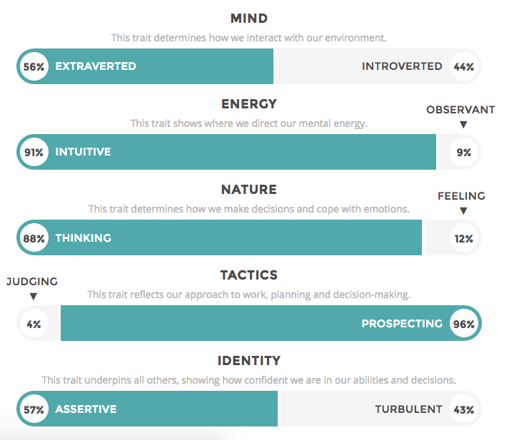
Learning Style Test
http://www.educationplanner.org/students/self-assessments/learning-styles-quiz.shtml
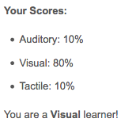
Emotional Intelligence Test
https://greatergood.berkeley.edu/quizzes/ei_quiz
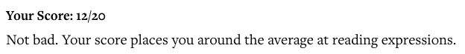
Although the results gained from these tests were not exactly what I had predicted, I can't say they come as any surprise. I relate to the ENTP-A personality type in that I definitely find myself driven towards challenges where I can use critical thought and creativity to find a solution. I've also always been keen to entertain and argue views that I might myself might not actually agree with, simply out of curiosity and enjoyment; on the website for the test, this personality type is also referred to as 'the devil's advocate' which is very fitting.

The learning style test is the one that I found most surprising as I had actually thought that I benefitted better from learning through listening. Thinking back however, I feel that this may be true as I definitely feel that my visual art is stronger than my musicality despite finding less enjoyment in it.

When finding myself working within a team, taking my personality type into account would be crucial. I think being of this personality type means that I will naturally move to assuming positions of authority. According to the description for ENTP-A found on the website linked, people my personality type have the tendency to be quite brutal in their evaluation of the opinions of others. They value logical ideas over ones shaped by emotional perspective. To be dismissive of others ideas can for obvious reason be seen as very insensitive. I would therefore need to acknowledge the downfalls of my personality and act accordingly to avoid possibly offending other members within the group.

Having a visual learning style may also shape my behave within a group, in that I may struggle to process information through non-visual mediums. A group phone call, for example, may leave me confused as I will automatically try to visualise the information received. Being of a visual learning style, I will also naturally default to explaining ideas visually. It would therefore be wise to take this into account by making sure I explain myself through a variety of ways.

My average score for emotional intelligence means that I will hopefully be competent in evaluating the mood within a working team. I personally think this is quite important as maintaining strong morale boosts productivity. Members of a team must be able to diffuse conflict, and be capable of understanding and empathising with others while in stressful situations. This is especially true for my personality type, as being aware of how others feel emotionally will help prevent behaving insensitively.

Project Ideas

Overview
My project will be the creation of an app designed to be utilised by users on smartphone devices. This app, GigAtlas, will show a map-oriented portrayal of all events on any given days within the users location. Taking user data from Facebook, the users may view all events they have clicked 'attending' to and 'interested in', as well explore events they are invited to and ones attended by their social circle. Each event 'node' will also detail links to stream music from the artists playing.

Motivation
Many Facebook users find themselves inundated with music event invitations. The 'Events' function provided by Facebook currently does not show visually the location of all events that the user intends to attend simultaneously. When planning one's night involves examining not just the locations of these events relative to each-other, but the genre of the music being played, it would seem that a service that can provide a simple visual representation to this information would be of high demand.

Description
Similar to apps like Messenger and Tinder, GigAtlas will require the user to give access to their Facebook page by logging in. In doing so, the user gives GigAtlas access all metadata for events attending and/or invited to for the user and their Facebook friends.

The home screen of the application will not be dissimilar to the application Uber, in that the user will be immediately greeted by a map of their current location showing their location at the centre. The screen will initially show the map with a 5km radius around the user. On the bottom-right corner of the map side is a function allowing the user to zoom in and out, thus revealing apps that fall inside or outside of the range shown (when closed, the chosen level of zoom will be saved and used again when the app is reopened).

Within a drop down menu, a calender function will allow the user to choose which dates they wish to view events for. The user will be able to create a list of 'tags' that they can attach to an event. This will be useful for users interested in a variety of musical genres, as they will be given the option to view a list of events sharing the same tag.

When the user clicks on an event, they will be shown the event information such as the time, promoter and description. This will not open the Facebook app, but be shown within the original app. Added to the event information will be a section that provides links to exterior sites, such as an artist's website or any locations in which the user may stream their music. Each event will have a share option, allowing to user to send information of the event through a range of other services (such as text message, Messenger, Email etc.).

The user can filter which events they're shown based on 'Attending', 'Interested in' and invitations they have not yet responded to. Similar to the feature available in Facebook, the user will be able to view a refined selection of events popular within their social circle. However, unlike Facebook, GigAtlas will display this as a map.

Tools and Technology
To identify user location GigAtlas will use the phone's GPS or data from the wifi network connection. Mongo DB will be used for the database framework. For the map oriented function, a mapping tool such as MapBox will be used. For the actual creation of the app the Java programming language will be used. A RestfulAPI will allow for the connection between the app and Facebook. For the front-end, Javascript and HTML5 will be harnessed to create the visuals.

Skills Required
The skills required include a strong knowledge in the programming languages and services listed above. Creating an app of such magnitude will not be capable alone, therefore hiring additional developers competent in these areas will be essential. Creating such an app would take a lot of time (perhaps 6+ months) , the initial investment must therefore be large enough to cover payment of all developers needed as well the cost of rent for the space in which development will occur.

